**Homework: Relational Algebra**

이름 : 전기범

학번 : 201703091

제출일 : 2019.10.16

**Query 1**: Retrieve the name and address of employees who work for the "Research" department.

Your output must be:

temp3(FNAME:VARCHAR,LNAME:VARCHAR,ADDRESS:VARCHAR)

Number of tuples = 4

Franklin:Wong:638 Voss, Houston, TX:

John:Smith:731 Fondren, Houston, TX:

Ramesh:Narayan:971 Fire Oak, Humble, TX:

Joyce:English:5631 Rice, Houston, TX:

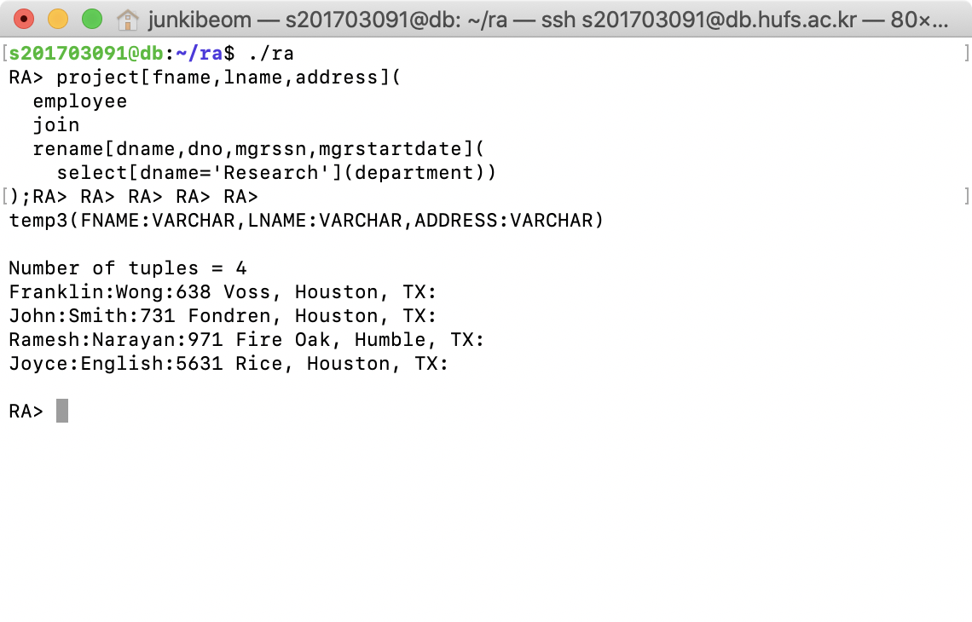

**My answer is CORRECT**

**Query 2**: For every project located in "Stafford", list the project number, the controlling department number, and the department manager's last name, address, and birth date.

Your output must be:

temp4(PNUMBER:INTEGER,DNUM:INTEGER,LNAME:VARCHAR,ADDRESS:VARCHAR,BDATE:VARCHAR)

Number of tuples = 2  
10:4:Wallace:291 Berry, Bellaire, TX:20-JUN-31:

30:4:Wallace:291 Berry, Bellaire, TX:20-JUN-31:

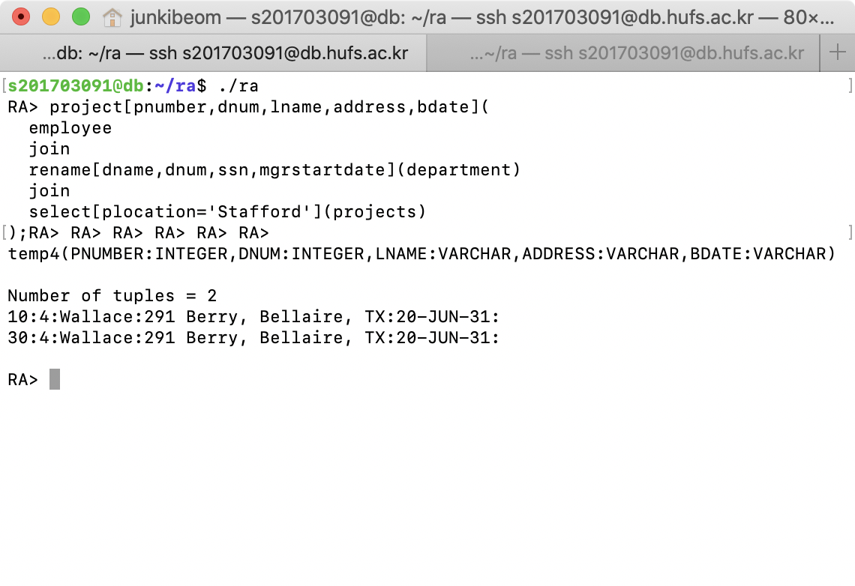

**My answer is CORRECT**

**Query 3**: Find the names of employees who work on all the projects controlled by department number 4.

Note that Division operator is NOT supported in RA interpreter

Your output must be:

temp11(LNAME:VARCHAR,FNAME:VARCHAR)

Number of tuples = 2

Zelaya:Alicia:

Jabbar:Ahmad:

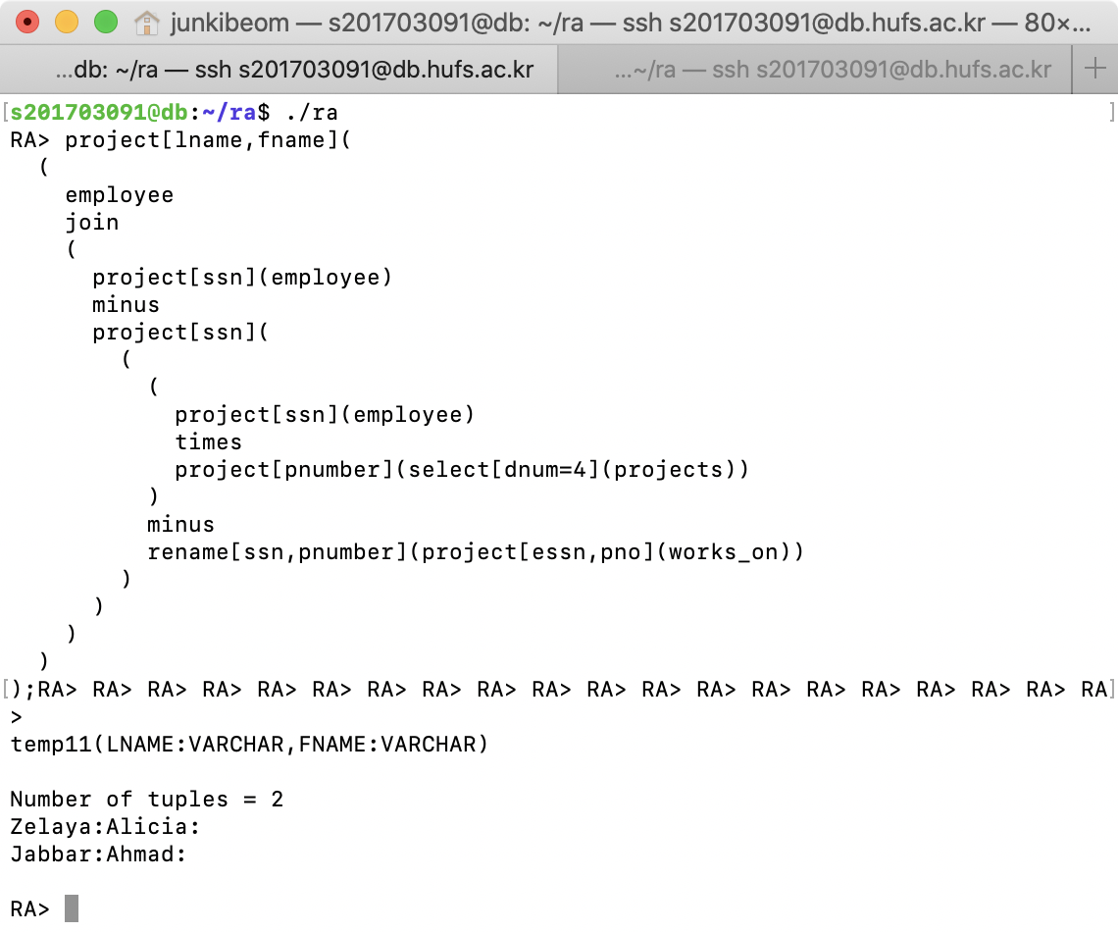

**My answer is CORRECT**

**Query 4**: Make a list of project numbers for projects that involve an employee whose last name is "Smith", either as a worker or as a manager of the department that controls the project.

renameYour output must be:

temp12(PNO:INTEGER)

Number of tuples = 2

1:

2:

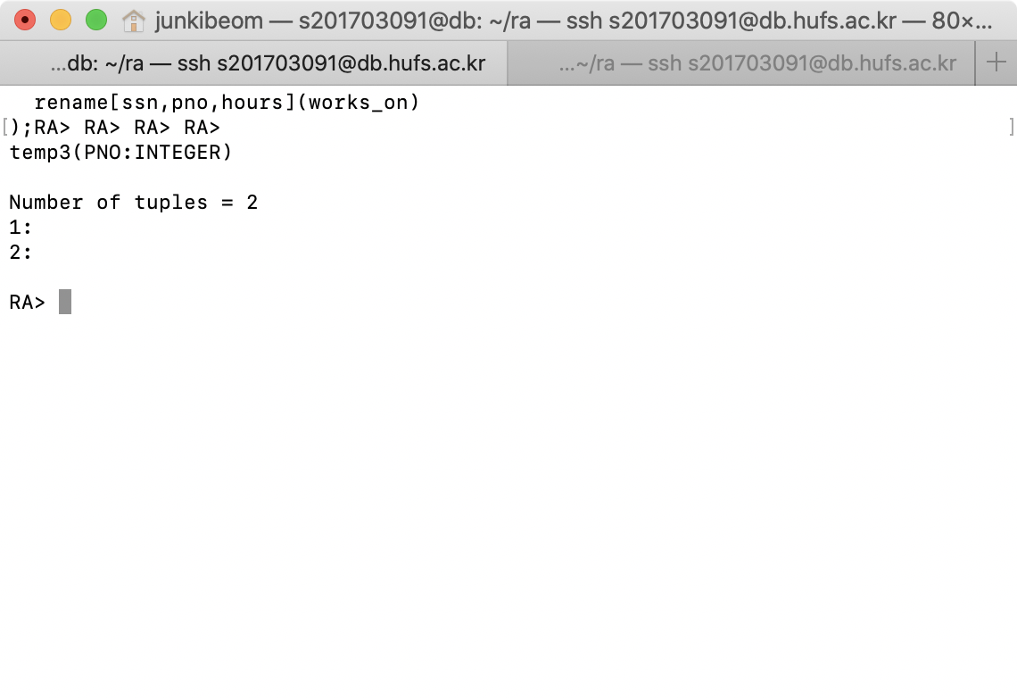

**My answer is CORRECT**

**Query 5**: List the names of all employees with two or more dependents.

Note that aggregation function is NOT supported in RA interpreter

Your output must be:

temp9(LNAME:VARCHAR,FNAME:VARCHAR)

Number of tuples = 2

Wong:Franklin:

Smith:John:

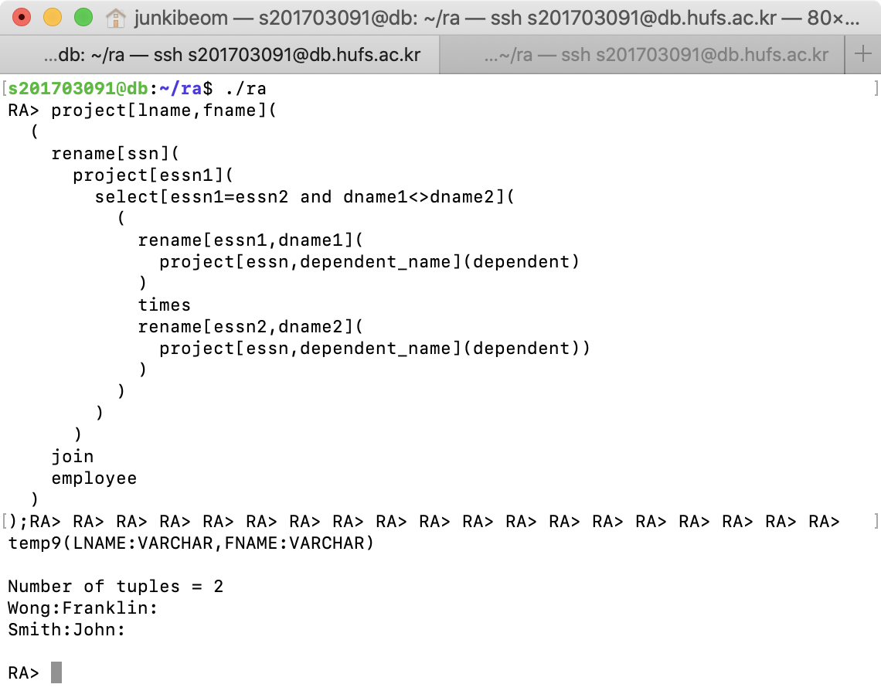

**My answer is CORRECT**

**Query 6**: Retrieve the names of employees who have no dependents.

Your output must be:

temp4(LNAME:VARCHAR,FNAME:VARCHAR)

Number of tuples = 5

Borg:James:

Zelaya:Alicia:

Narayan:Ramesh:

English:Joyce:

Jabbar:Ahmad:

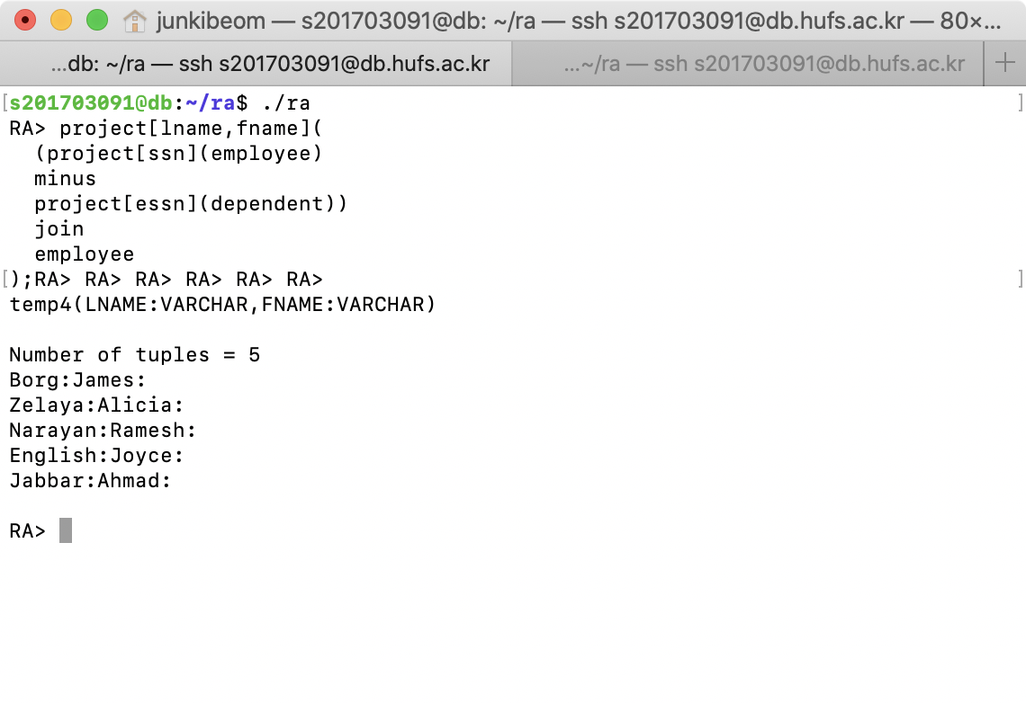

**My answer is CORRECT**

**Query 7**: List the names of managers who have at least one dependent.

Your output must be:

temp6(LNAME:VARCHAR,FNAME:VARCHAR)

Number of tuples = 2

Wong:Franklin:

Wallace:Jennifer:

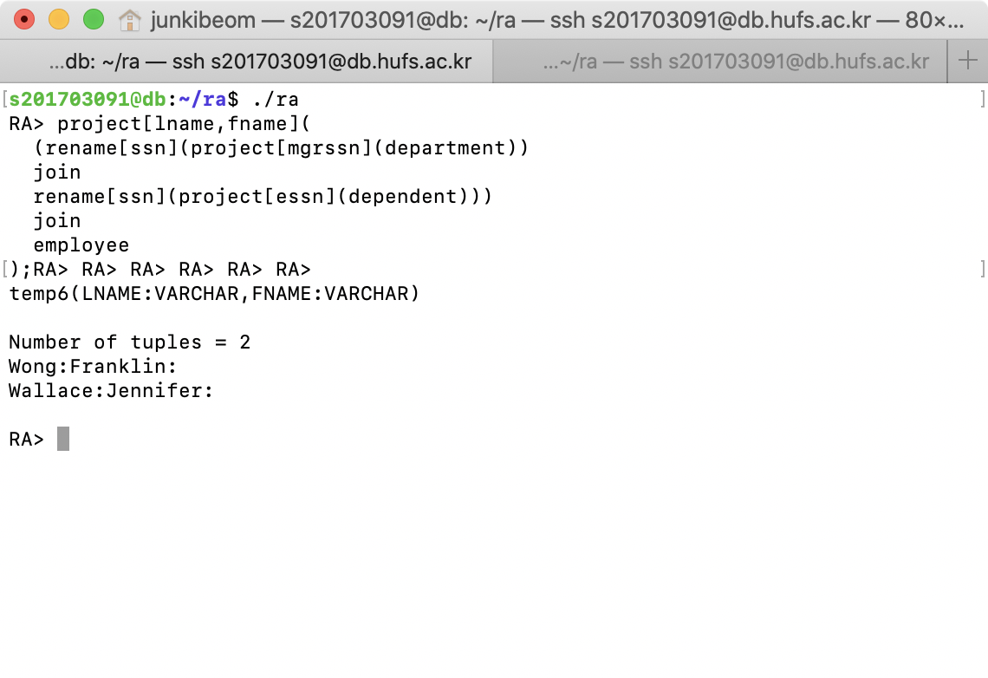

**My answer is CORRECT**

**Query 8**: Retrieve the names of all employees who do not work on any project number 1. Your output must be:

temp5(LNAME:VARCHAR,FNAME:VARCHAR)

Number of tuples = 6

Borg:James:

Wong:Franklin:

Wallace:Jennifer:

Zelaya:Alicia:

Narayan:Ramesh:

Jabbar:Ahmad:

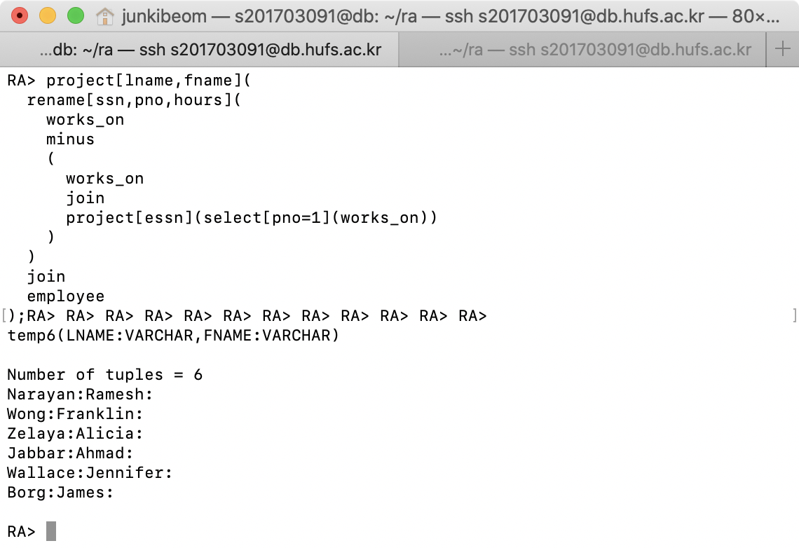

**My answer is CORRECT**

**Query 9**: List the last names of all department managers who have no dependents.

Your output must be:

temp5(LNAME:VARCHAR,FNAME:VARCHAR)

Number of tuples = 1

Borg:James:

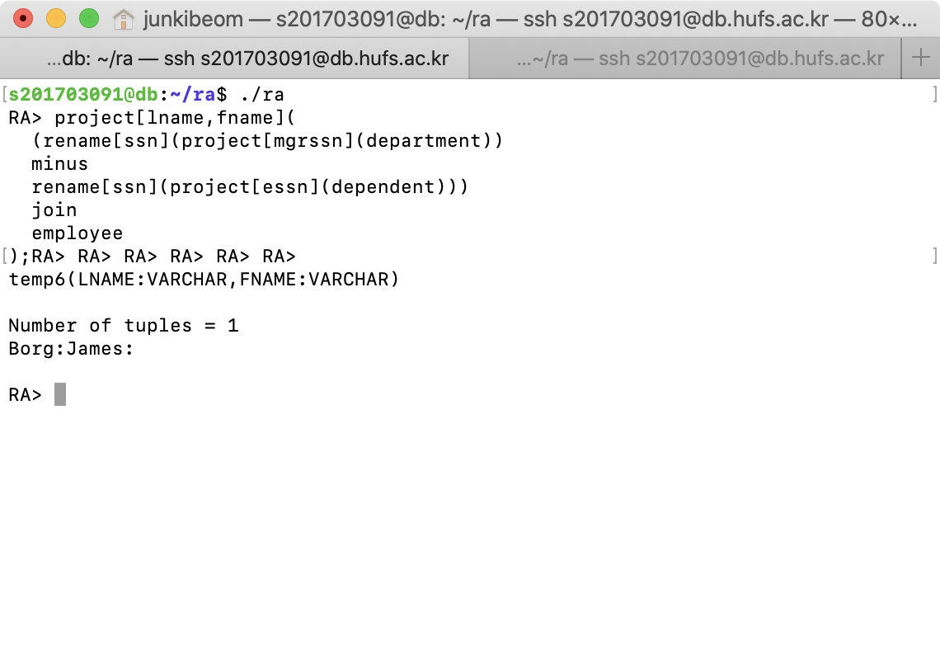

**My answer is CORRECT**

**Query 10**: Retrieve the names of all employees in department 5 who work more

than 10 hours per week on the ProductX project.

Your output must be:

temp6(LNAME:VARCHAR,FNAME:VARCHAR)

Number of tuples = 2

Smith:John:

English:Joyce:

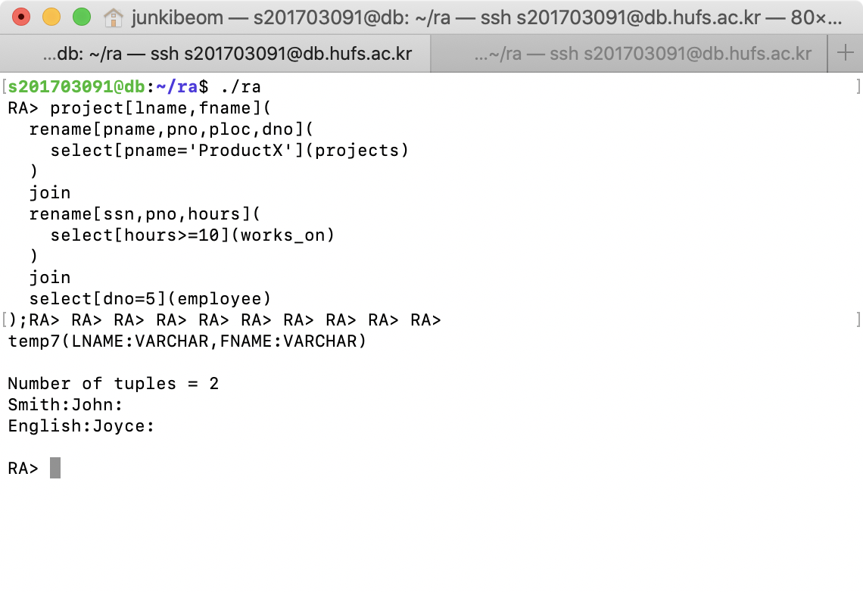 **My answer is CORRECT**

**Query 11**: Find the names and addresses of all employees who work on at least one project located in Houston but whose department has no location in Houston.

Your output must be:

temp13(LNAME:VARCHAR,FNAME:VARCHAR,ADDRESS:VARCHAR)

Number of tuples = 1  
Wallace:Jennifer:291 Berry, Bellaire, TX:

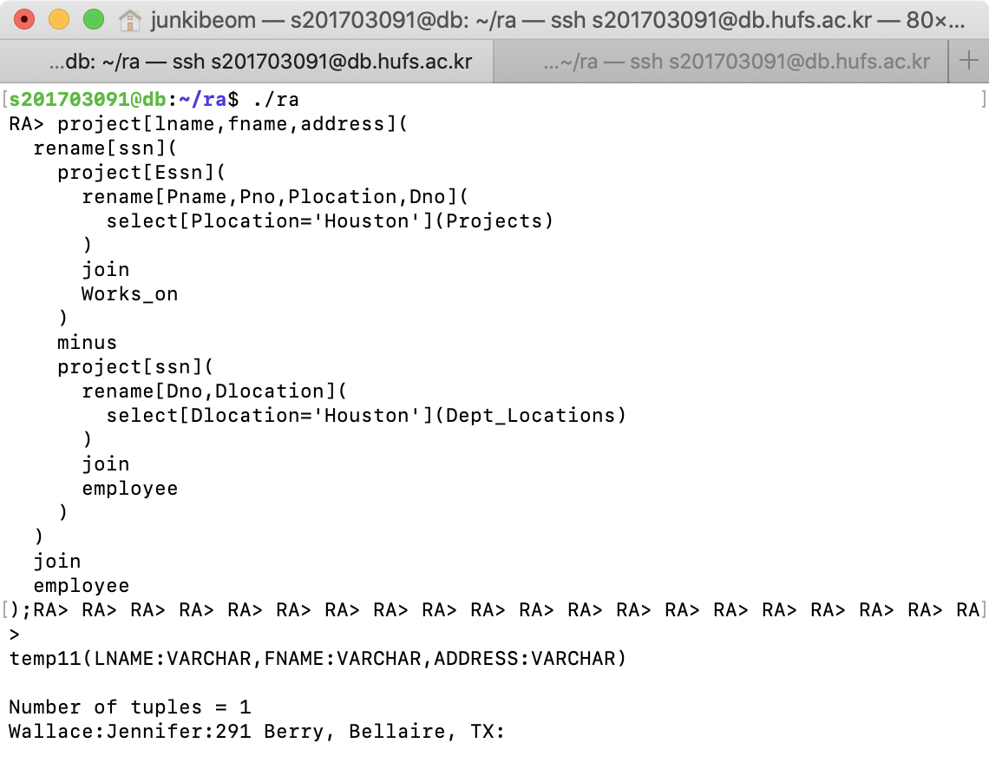

**My answer is CORRECT**